ME 396: CML A8 GAN Journey Revisited

This is a journey inspired by the short story “The Egg” by Andy Weir. I made the image scenes of this journey with Max Woolf’s VQGAN + CLIP colab, link below. All scenes generated were made using a seed number of 42. I also used Masatoshi Hidaka’s Chainer Image Caption demo to generate captions from the generated images using a machine learning model trained on the MSCOCO dataset.

<https://colab.research.google.com/drive/1wkF67ThUz37T2_oPIuSwuO4e_-0vjaLs?usp=sharing#scrollTo=clJsMT0Eqizk>

<https://milhidaka.github.io/chainer-image-caption/>

<https://github.com/milhidaka/chainer-image-caption>

Scene 1

Prompt: “man dying in a car accident by Claude Monet”

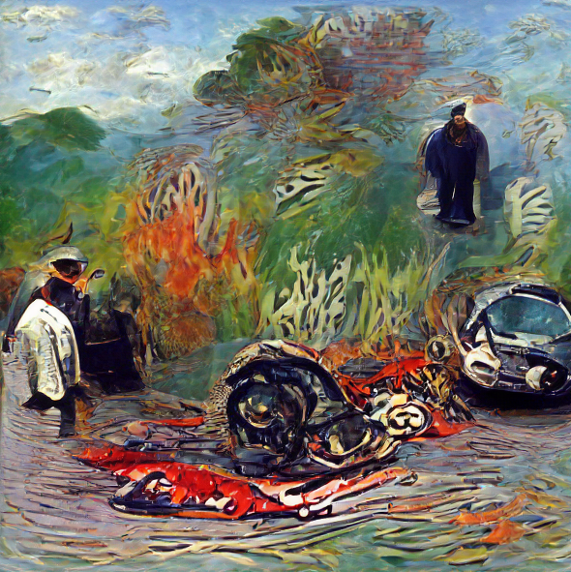

A car accident killed a man. But it also cut down a family. His wife and children were left to fend for themselves.

Generated captions:

a group of people riding on the backs of elephants

a group of people riding on the backs of horses

a group of people riding skis on a snowy surface

a group of people sitting on a boat

a group of people that are standing in the snow

a group of people riding on the back of a boat

a group of people that are standing in the water

a group of people sitting on top of a boat

a group of people riding on the backs of surfboards

a group of people riding on the back of a motorcycle

Scene 2

Prompt: “man meeting God by Claude Monet”

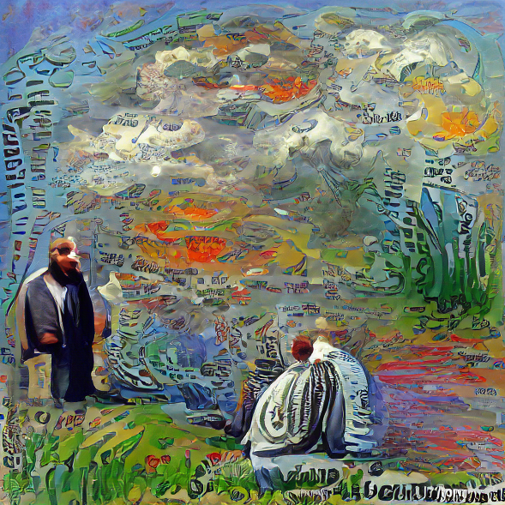

After his death, the man expected to meet God as his religion taught him. He expected to go live on in the afterlife.

Generated captions:

a group of people sitting around a table

a group of people sitting on a bench

a group of people sitting on a wooden bench

a group of people sitting at a table

a group of people that are sitting on a bench

a group of people sitting at a table with umbrellas

a group of people sitting around a table with umbrellas

a group of people sitting on a bench in a park

a group of people sitting on a bench in the snow

a group of people sitting at a table with a large umbrella

Scene 3

Prompt: “man speaking with his grammar school teacher by Claude Monet”

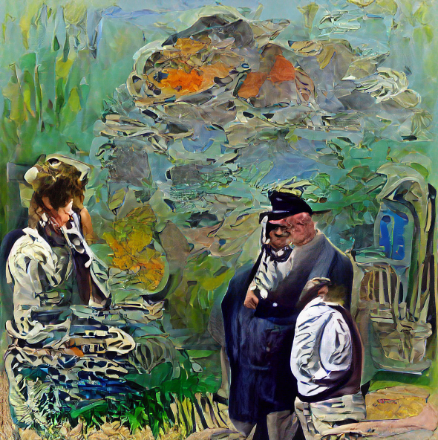

But the man met someone who did not look like a god. Instead, the man was speaking to someone that reminded him of one of his old school teachers.

Generated captions:

a group of people standing next to each other

a group of people that are standing in the snow

a group of people sitting on a bench

a couple of people that are standing in the snow

a group of people that are standing in the grass

a group of people that are standing in the dirt

a couple of people that are standing in the grass

a group of people standing next to each other on a field

a group of people standing next to each other in a field

a group of people standing next to each other on a beach

Scene 4

Prompt: “wife and kids at funeral by Claude Monet”

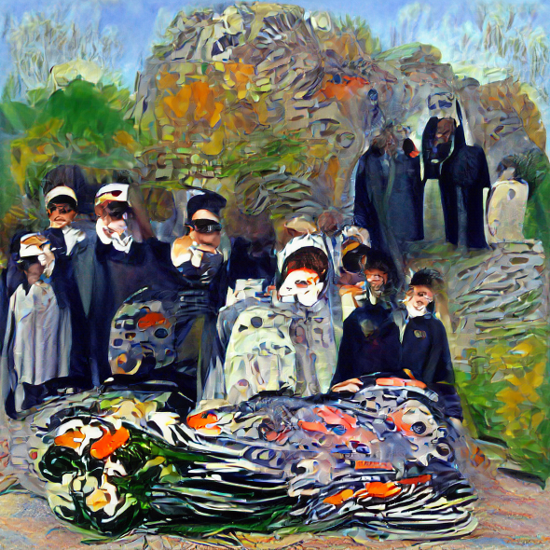

The man asks how his family is faring without him. At the funeral, the wife is both relieved and in grief over his death. The children remember him as a good father. They live a good life without him.

Generated captions:

a group of people sitting around a table

a group of people standing around a table

a large group of people sitting around a table

a group of people sitting around a table with food

a group of people sitting at a table with food

a large group of people sitting at a table

a group of people are sitting at a table

a group of people sitting around a table eating food

a group of people sitting around a table with a cake

a group of people sitting at a table with food and drinks

Scene 5

Prompt: “man asking for the meaning of life by Claude Monet”

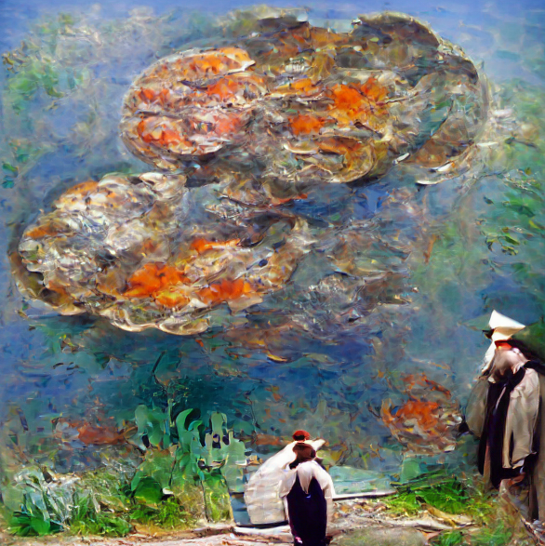

After understanding that his family will be okay, the man asks for the meaning of life. The god explains that the universe was made for him to mature.

Generated captions:

a group of people sitting on a bench

a group of people that are standing in the snow

a couple of people that are sitting on a bench

a couple of people that are standing in the snow

a group of people sitting on a wooden bench

a group of people that are sitting in the snow

a group of people that are sitting on a bench

a group of people standing on top of a sandy beach

a group of people that are standing in the dirt

a group of people standing on top of a beach

Scene 6

Prompt: “Abraham Lincoln giving a speech by Claude Monet”

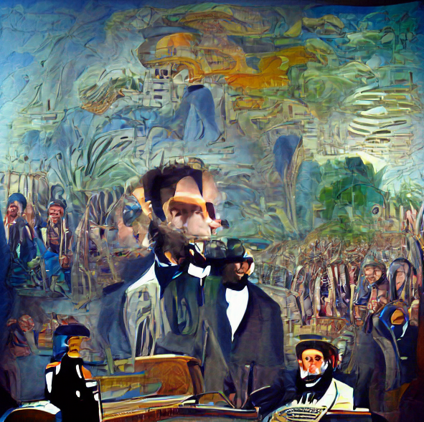

The god says that every individual in the history of humankind has been him. Every time he interacted with someone else, it was him.

Generated captions:

a group of people sitting around a table

a group of people sitting at a table

a group of people sitting around a dinner table

a group of people sitting at a table with wine glasses

a group of people are sitting at a table

a group of people sitting around a table with wine glasses

a group of people sitting at a table with drinks

a group of people sitting at a table in a restaurant

a group of people sitting around a table in a room

a group of people sitting at a table in a room

Scene 7

Prompt: “small child by Claude Monet”

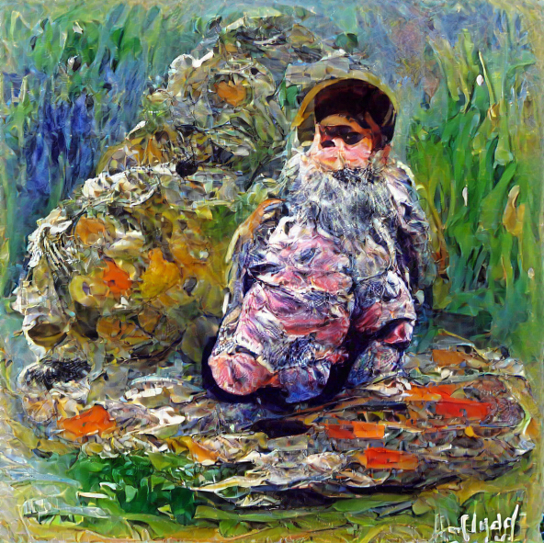

After this chat, it is time for the man to continue to mature by being reborn as a child and living another one of his lives.

Generated captions:

a group of people sitting around a table

a group of people sitting at a table

a group of people sitting around a table with food

a group of people sitting at a table with food

a man sitting at a table with a plate of food

a woman sitting at a table with a plate of food

a man sitting at a table with a bunch of food

a man sitting at a table with a bunch of bananas

a woman sitting at a table with a bunch of food

a woman sitting at a table with a bunch of bananas